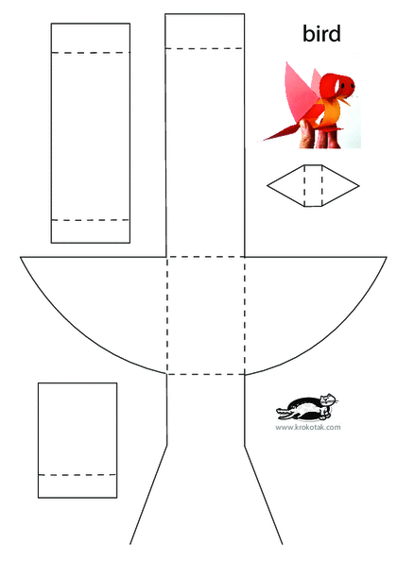

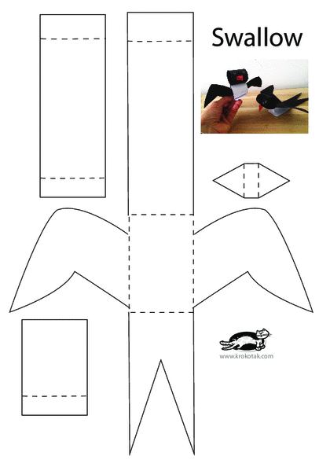

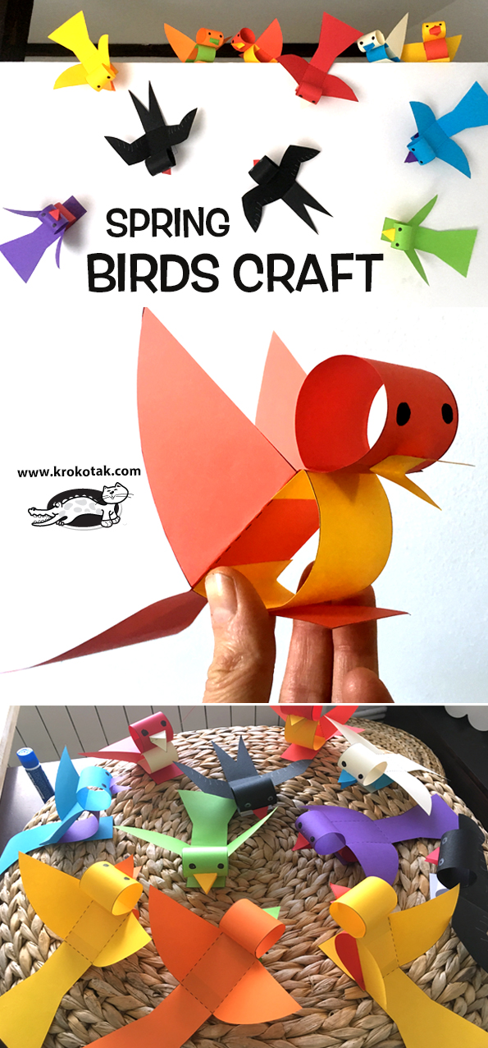
http://krokotak.com/2019/02/spring-birds-craft/?fbclid=IwAR2e0nXB1B4VPiZCEHHl-bbVg50V43ZDtbphE92vsb8rlcMelFbT87Xilf0

